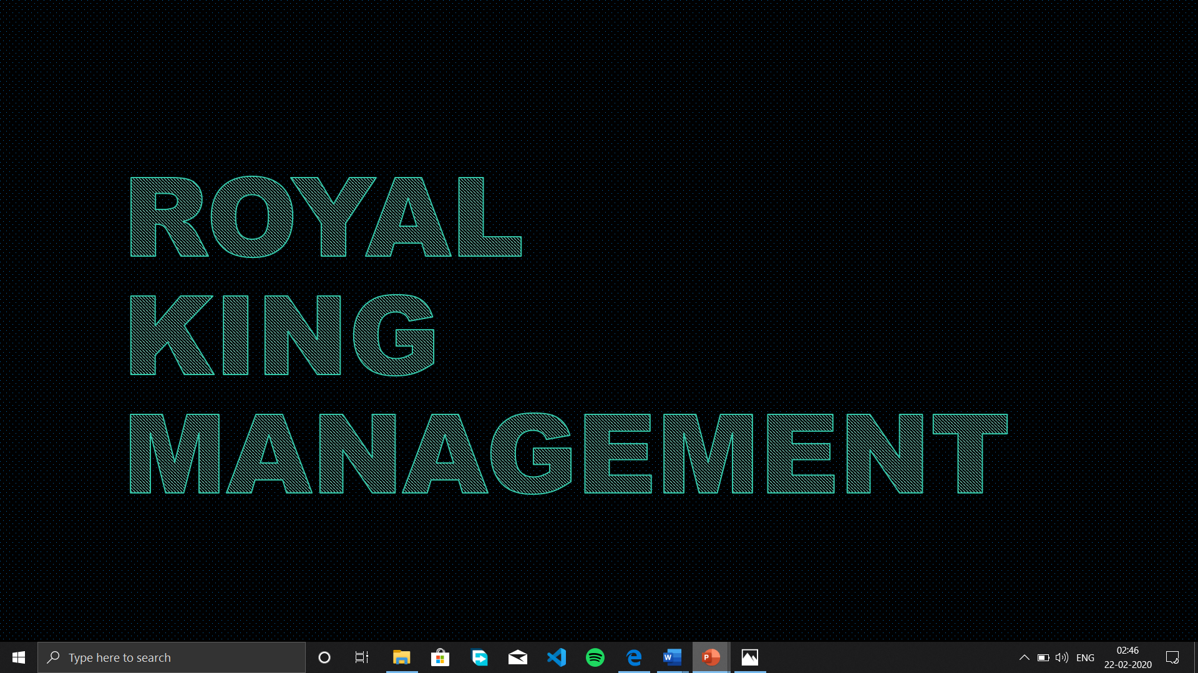

SECTION: K19HZ

* GROUP MEMBERS:
* VAIBHAV SAXENA---------------------------------ROLLNO.-->41
* KURITI JAYA SAI------------------------------------ROLLNO.-->39
* NARAPUREDDY KUSHAL KUMAR REDDY-----ROLNO.-->40

* SUBMITTED TO: MRS. MANU BALI

IN THIS PROJECT WE ARE GOING TO CREATE AN ONLINE EVENT MANAGEMENT SYSTEM SITE USING HTML.

WE HAVE PLANNED AND GOING TO CREATE AS PER THE DESIGN GIVEN BY THE INSTRUCTOR.

WHICH INCLUDE:

* HOME PAGE WHICH WILL PROVIDE ALL THE NESSESARY VIEW
* TOP PANEL WHICH WILL CONTAIN DIFFERENT TYPES OF EVENTS
* DIFFERENT KINDS OF MANAGING WIL BE PROVIDED
* USERS CAN SIGNUP AND LOGIN WITH THEIR ID
* USERS CAN CONTACT US THROUGH EMAIL OR VIA CALL
* WE WILL PROVIDE SOME ADD-ONS AND SPECIAL PACKAGES ON CERTAIN CONDITIONS
* EVENT DETAILS SHOULD BE PROVIDED AND ACCORDINGLY THEY HAVE TO MAKE THE PAYMENT

CONCEPT

* WE HAVE USED THE CONCEPT OF HTML PROGRAMMING LIKE:

HYPERLINK REDIRECTION

* USE OF DIFFERENT TAGS TO MAKE IT MORE INTERACTIVE LIKE FONT, TABLE, LISTING, HYPERLNK, STYLING ETC.  USE OF: -
  + COMBOBOX
  + BUTTON
  + TEXTFIELD
  + LABEL

THIS PROJECT IS BASICALLY ABOUT EVENT MANAGEMENT SYSTEM WHERE ONE CAN CONTACT US FOR THEIR WHOLE EVENT MANAGING. WE PROVIDE DIFFERENT TYPES OF EVENTS WITH SOME CUSTOMIZATION.

ALL DESIGNING AND PROGRAMING ARE DONE BY US.

AND ALL THE MEMBER HAVE THEIR ROLE IN CREATING THIS WEBSITE IN HTML LANGUAGE.